**Plaice (*Pleuronectes platessa*) in Division 7.d (eastern English Channel)**

ICES advice on fishing opportunities

ICES advises that when the MSY approach is applied, catches in 2024 should be no more than 2 367 tonnes.

The use of a combined TAC for plaice in divisions 7.d and 7.e prevents effective control of single stock exploitation rates and could lead to the overexploitation of either stock. ICES advises that management should be implemented at the stock area level.

ICES notes the existence of a precautionary management plan, developed and adopted by one of the relevant management authorities for this stock.

ICES advice on conservation aspects

ICES has not identified any conservation aspects.

**Stock development over time**

Fishing pressure on the stock is above FMSY but below Fpa and Flim, and spawning-stock size is below MSY Btrigger and between Bpa and Blim.

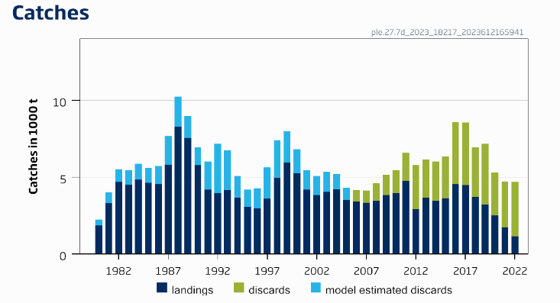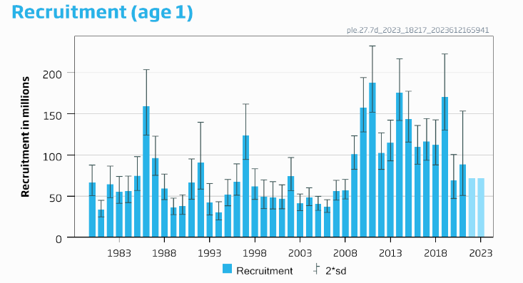

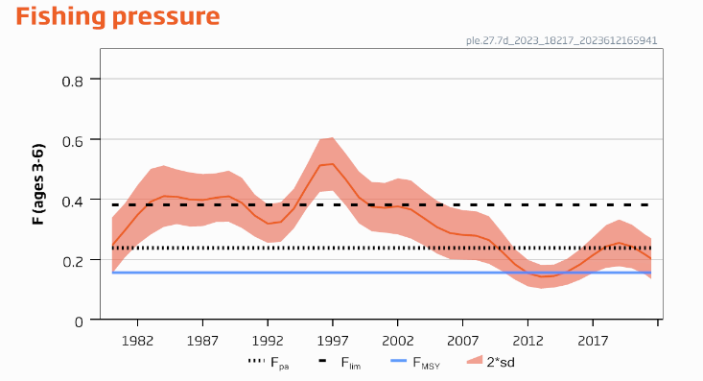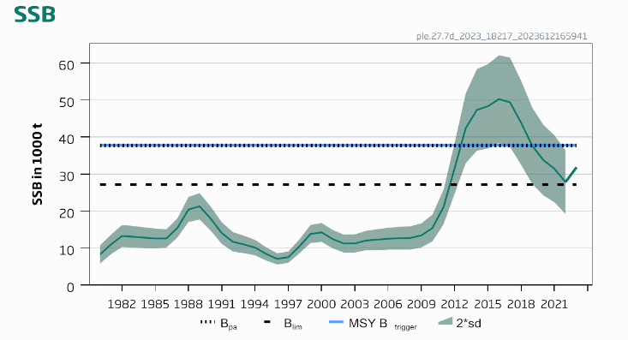

**Figure 1** Plaice in Division 7.d. Summary of the stock assessment. The assumed recruitment value for 2022 and 2023 is shaded in a lighter colour. Discard data are only available since 2006; values prior to that are model estimates. Discards include BMS (below minimum size) landings.

**Conservation status**

ICES is not aware of any information on stock/species-specific conservation status.

Catch scenarios

**Table 1** Plaice in Division 7.d. Values in the forecast and for the interim year for Division 7.d plaice stock only.

| Variable | Value | Notes |
| --- | --- | --- |
| Fages 3–6 (2023) | 0.187 | Average exploitation pattern (2020–2022), scaled to Fages 3–6 2022 |
| SSB (2024) | 28864 | Short-term forecast (STF); in tonnes |
| Rage 1 (2022–2024) | 71768 | Geometric mean 1980–2021; in thousands |
| Total catch (2023) | 3714 | STF; in tonnes |
| Projected landings (2023) | 1594 | STF; assuming average landings ratio (2020–2022); in tonnes |
| Projected discards (2023) | 2120 | STF; assuming average discards ratio (2020–2022); in tonnes |

**Table 2** Plaice in Division 7.d. Annual catch scenarios. Weights are in tonnes.

| Basis | Division 7.d plaice stock | | | | | | | | | All plaice in Division 7.d# | | | | |
| --- | --- | --- | --- | --- | --- | --- | --- | --- | --- | --- | --- | --- | --- | --- |
| Total catch (2024)^ | Projected landings (2024) | Projected discards* (2024) | Ftotal  (ages 3−6) (2024) | Fprojected landings  (ages 3–6) (2024) | Fprojected discards  (ages 3–6) (2024) | SSB  (2025) | % SSB change  ** | % advice change$ | Total catch (2024) | Projected landings (2024) | Projected discards* (2024) | % change in projected catches^^ | % advice change## |
| ICES advice basis | | | | | | | | | | | | | | |
| MSY approach: FMSY× SSB (2024)/MSY Btrigger | 2367 | 1058 | 1309 | 0.119 | 0.029 | 0.090 | 29 594 | 2.5 | −50 | 2826 | 1263 | 1562 | −62 | −50 |
| Other scenarios | | | | | | | | | | | | | | |
| F = FMSY lower× SSB (2024)/ MSY Btrigger | 1737 | 777 | 960 | 0.086 | 0.021 | 0.065 | 30 449 | 5.5 | −63 | 2074 | 927 | 1146 | −72 | −63 |
| FMSY lower | 2249 | 1005 | 1243 | 0.113 | 0.028 | 0.085 | 297 54 | 3.1 | −53 | 2684 | 1200 | 1484 | −64 | −53 |
| FMSY | 3052 | 1364 | 1688 | 0.156 | 0.038 | 0.118 | 28 668 | −0.68 | −36 | 3643 | 1628 | 2015 | −52 | −36 |
| F = 0 | 0 | 0 | 0 | 0 | 0 | 0 | 32 828 | 13.7 | −100 | 0 | 0 | 0 | −100 | −100 |
| Fpa | 4510 | 2014 | 2496 | 0.238 | 0.058 | 0.180 | 26 714 | −7.5 | −4.8 | 5383 | 2403 | 2980 | −28 | −5.1 |
| Flim | 6836 | 3047 | 3789 | 0.381 | 0.093 | 0.29 | 23 644 | −18.1 | 44 | 8160 | 3637 | 4523 | 8.5 | 44 |
| SSB (2025) = Blim | 4185 | 1869 | 2316 | 0.22 | 0.054 | 0.166 | 27 147 | −5.9 | −11.7 | 4996 | 2231 | 2765 | −34 | −11.9 |
| SSB (2025) = Bpa = MSY Btrigger ### |  |  |  |  |  |  |  |  |  |  |  |  |  |  |
| F = F2023 | 3611 | 1613 | 1998 | 0.187 | 0.046 | 0.141 | 27 917 | −3.3 | −24 | 4310 | 1925 | 2384 | −43 | −24 |

* Including BMS landings, assuming recent discard rate.

** SSB 2025 relative to SSB 2024.

$ Total catch of plaice stock in 2024 relative to the advice value 2023 (4738 tonnes).

^ Differences between total catch and the sum of projected landings and discards result from rounding.

^^ Total catch of plaice in Division 7d in 2024 relative to the ICES estimates of catches in 2022 (7520 tonnes).

# All plaice in Division 7.d, including plaice originating from the North Sea and the western English Channel. Of the plaice caught in Division 7.d, 12.49% are assumed to originate from the North Sea and 3.75% from the western English Channel (average ratio calculated over the years 2003–2022). Both of these predicted catches are added to the predicted values for the ple.27.7d stock and applied to total catch, projected landings, and projected discards. Following ICES advice basis, catches in Division 7.d will comprise 2367 tonnes coming from the ple.27.7d stock, plus 352 tonnes coming from the ple.27.420 stock and 106 tonnes from the ple.27.7e stock.

## Total catch of plaice in division 7d in 2024 relative to the advice value 2023 (5671 tonnes).

### Bpa and MSY Btrigger cannot be achieved in 2025, even with zero catches.

The advice change (−50% for the Division 7.d plaice stock) is the result of a large decrease in the recruitment assumption and a downward revision in SSB in recent years, leading to a reduction in the target F below FMSY.

Basis of the advice

**Table 3** Plaice in Division 7.d. The basis of the advice.

|  |  |
| --- | --- |
| Advice basis | MSY approach. |
| Management plan | ICES is aware of the multiannual management plan (MAP) that has been adopted by the EU for this stock (EU, 2019) and that ICES considers to be precautionary. There is no agreed shared management plan with UK for this stock, and ICES provides advice according to ICES MSY approach. Catch scenarios consistent with the MAP FMSY ranges are provided. |

Quality of the assessment

There is uncertainty about catches of the Division 7.d plaice stock because of migrations between Division 7.d and the North Sea and the western English Channel during the spawning period. The current assessment results depend on the proportion of first quarter removals estimated from a historical tagging survey (ICES, 2010).

During 2022, the FR-GFS survey did not have access to the waters within six nautical miles of the UK coast; therefore, all stations within this area were not sampled. This area is an important habitat for plaice. The effect of this issue has been investigated and, although one year of missing stations did not have a substantial impact on the current assessment outputs, it may become a problem if the issue persists in the future.

There has been no UK-BTS survey in the eastern English Channel in 2022. This resulted in high uncertainty for the 2022 recruitment estimate. Due to the high uncertainty, the recruitment value for 2022 was not used in the forecast and was replaced with the assumed recruitment value for 2023.

The current intermediate year assumption for the recruitment is based on a geometric mean for 1980–2021. This is in contrast to last year, where a shorter recruitment period was used in line with a higher recruitment period in the most recent years.

There has been a downwards revision in SSB. The reason for this is unclear.

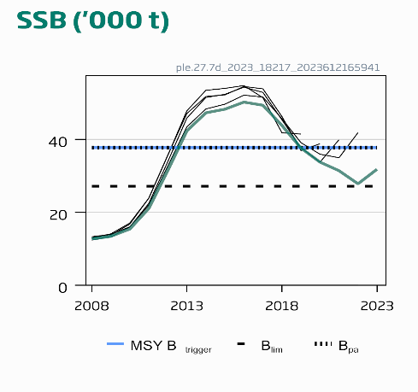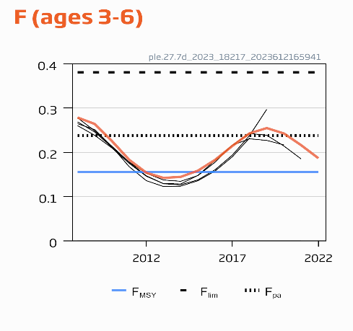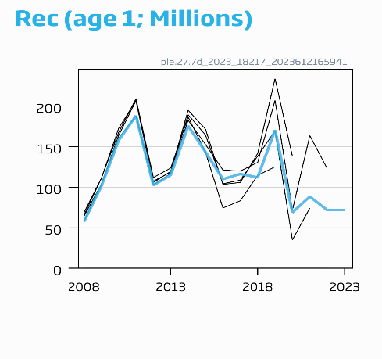

**Figure 2** Plaice in Division 7.d. Historical assessment results (final-year recruitment included for each line, corresponding to the forecast recruitment in the interim year). The reference points were revised in 2022, and only assessment results from the last two years should be compared to the reference points indicated.

Issues relevant for the advice

A single TAC covers both divisions 7.d and 7.e; management should ensure that fishing opportunities are in line with the stock status for each of the stocks in the combined management area to ensure that both stocks are exploited sustainably.

Mature individuals from plaice stock in Division 7.e and stock in Subarea 4 and Subdivision 20 migrate to Division 7.d in the first quarter. Thus, a proportion of catch of these two stocks occurs in Division 7.d. For the ple.27.7e, ple.27.7d, and ple.27.420 stocks, the catch advice is given at stock level but the catch corresponding to each area is provided in the catch scenario table. Of the plaice caught in Division 7.d, 12.49% is assumed to originate from the North Sea and 3.75% from the western English Channel (average ratio calculated over the years 2003–2022); both of these predicted catches are added to the predicted values for the ple.27.7d stock and applied to total catch, projected landings, and projected discards. Following ICES advice basis, catches in Division 7.d will comprise 2367 tonnes from the ple.27.7d stock, plus 352 tonnes from the ple.27.420 stock and 106 tonnes from the ple.27.7e stock. All catch scenarios for ple.27.7e and ple.27.420 stocks assume that fishing opportunities for ple.27.7d stock in 2024 correspond to the “ICES basis for the advice scenario”; for the ple.27.7d stock, however, this amount depends on the scenario.

Plaice is caught in a mixed fishery targeting sole, with 80 mm mesh size. This leads to a large number of plaice being discarded because this mesh size does not match the minimum conservation reference size (MCRS).

Reference points

**Table 4** Plaice in Division 7.d. Reference points, values, and their technical basis.

| Framework | Reference point | Value | Technical basis | Source |
| --- | --- | --- | --- | --- |
| MSY approach | MSY Btrigger | 37761 | Bpa; in tonnes | ICES (2022a) |
| FMSY | 0.156 | EqSim analysis based on recruitment period 1980–2020 | ICES (2022a) |
| Precautionary approach | Blim | 27174 | Break-point of hockey stick stock–recruit relationship, based on recruitment period 1980–2020; in tonnes | ICES (2022a) |
| Bpa | 37761 | Blim × exp (1.645 × 𝜎) ≈ 1.4 × Blim, 𝜎 = 0.20; in tonnes | ICES (2022a) |
| Flim | 0.381 | EqSim analysis based on recruitment period 1980–2020 | ICES (2022a) |
| Fpa | 0.238 | The F that provides a 95% probability for SSB to be above Blim (Fp.05 with advice rule [AR]) | ICES (2022a) |
| EU Management plan (MAP)* | MAP MSY Btrigger | 37761 | MSY Btrigger; in tonnes | ICES (2022a) |
| MAP Blim | 27174 | Blim; in tonnes | ICES (2022a) |
| MAP FMSY | 0.156 | FMSY | ICES (2022a) |
| MAP range Flower | 0.113–0.156 | Consistent with ranges resulting in no more than 5% reduction in long-term yield compared with MSY | ICES (2022a) |
| MAP range Fupper | 0.156–0.224 | Consistent with ranges resulting in no more than 5% reduction in long-term yield compared with MSY | ICES (2022a) |

* EU multiannual plan (MAP) for the Western Waters (EU, 2019).

Basis of the assessment

**Table 5** Plaice in Division 7.d. Basis of the assessment and advice.

|  |  |
| --- | --- |
| ICES stock data category | 1 ([ICES, 2023a](https://doi.org/10.17895/ices.advice.22240624)) |
| Assessment type | Age-based analytical assessment (AAP; Aarts and Poos, 2009) that uses catches in the model and in the forecast (ICES, 2023b) |
| Input data | Commercial catch (international landings, with age frequencies from catch sampling covering 65% of the landings) and two survey indices: UK-BTS [B2453] and FR-GFS index [G3425] (calculated with delta GAM). Time invariant natural mortality by age is calculated from Peterson and Wroblewski (1984). Fixed maturity ogive is based on biological sampling. |
| Discards and bycatch | Discards are included in the assessment, and all major fleets are covered. In 2022, 69% of the landings had associated discard information, with age frequencies from catch sampling covering 53% of the discards. 72% of the discard estimates are based on observations. The model reconstructs discards for years where data are not available (before 2006). |
| Indicators | None |
| Other information | Last benchmarked in 2015 (WKPLE; ICES, 2015), Reference points updated in 2022 (WGNSSK; ICES, 2022a). Catches from Division 7.d are reduced by the amount of plaice that originate from the ple.27.420 stock and the ple.27.7e stock. The catches originating from ple.27.420 and ple.27.7e stocks are assumed to be, respectively, 50% and 15% of the mature individuals caught in Division 7.d during the first quarter, derived from tagging data (ICES, 2010). |
| Working group | Working Group on the Assessment of Demersal Stocks in the North Sea and Skagerrak ([WGNSSK](http://www.ices.dk/community/groups/Pages/WGNSSK.aspx)) |

**History of the advice, catch, and management**

**Table 6** Plaice in Division 7.d. History of ICES advice, official landings for plaice in Division 7.d, agreed TAC for divisions 7.d and 7.e, and ICES estimates for landings and discards of Division 7.d plaice and for plaice in Division 7.d. Weights are in tonnes.

| Year | ICES advice | Landings corresponding to advice | | | Catch corresponding to advice | | Agreed TAC  7.d, e | Official landings of plaice in 7.d* | ICES landings of plaice in 7.d* | ICES landings 7.d plaice | ICES discards of 7.d plaice | ICES discards of plaice in 7.d^^ |
| --- | --- | --- | --- | --- | --- | --- | --- | --- | --- | --- | --- | --- |
| 7.d plaice | Plaice in 7.d | Plaice in 7.d–e | 7.d plaice stock | Plaice in 7.d |
| 1987 | Precautionary TAC for 7.d–e |  |  | 6800 |  |  | 8300 | 7867 | 8366 | 7006 |  |  |
| 1988 | Precautionary TAC for 7.d–e |  |  | 6900 |  |  | 9960 | 9103 | 10420 | 8785 |  |  |
| 1989 | No increase in effort for 7.d–e |  |  | 11700 |  |  | 11700 | 7115 | 8758 | 7093 |  |  |
| 1990 | No increase in F; TAC for 7.d–e |  |  | 10700 |  |  | 10700 | 8367 | 9047 | 7349 |  |  |
| 1991 | TAC for 7.d–e |  |  | 8800 |  |  | 10700 | 7913 | 7813 | 6362 |  |  |
| 1992 | *Status quo* F gives mean SSB |  | 7600 |  |  |  | 9600 | 6232 | 6337 | 5219 |  |  |
| 1993 | *Status quo* F within safe biological limits |  | 6400 |  |  |  | 8500 | 4771 | 5331 | 4479 |  |  |
| 1994 | No long-term gains in increased F |  | - |  |  |  | 9100 | 5633 | 6121 | 5047 |  |  |
| 1995 | No increase in F |  | 5600 |  |  |  | 8000 | 4569 | 5130 | 4196 |  |  |
| 1996 | No long-term gains in increasing F |  | 6500 |  |  |  | 7530 | 4598 | 5393 | 4430 |  |  |
| 1997 | No advice |  | - |  |  |  | 7090 | 5316 | 6307 | 5180 |  |  |
| 1998 | Reduce F in 1998 by 30% from 1996 value |  | 4300 |  |  |  | 5700 | 4830 | 5762 | 4831 |  |  |
| 1999 | Fishing at Fpa |  | 6300 |  |  |  | 7400 | 5437 | 6326 | 5268 |  |  |
| 2000 | Fishing at Fpa |  | 4900 |  |  |  | 6500 | 5235 | 6014 | 4521 |  |  |
| 2001 | Fishing at < Fpa |  | < 4400 |  |  |  | 6000 | 4968 | 5266 | 4380 |  |  |
| 2002 | Fishing at < Fpa |  | < 5800 |  |  |  | 6700 | 5496 | 5777 | 4846 |  |  |
| 2003 | Fishing at < Fpa |  | < 5300 |  |  |  | 5970 | 4650 | 4086 | 3610 |  |  |
| 2004 | Fishing at < Fpa** |  | < 5400 |  |  |  | 6060 | 4312 | 4750 | 4206 |  |  |
| 2005 | Fishing at < Fpa** |  | < 4400 |  |  |  | 5150 | 3706 | 3991 | 3485 |  |  |
| 2006 | No effort increase** |  |  |  |  |  | 5151 | 3525 | 3646 | 3225 | 727 | 749 |
| 2007 | Average landings** |  | < 4000 |  |  |  | 5050 | 3845 | 4001 | 3381 | 1220 | 1252 |
| 2008 | Average landings** |  | < 3500 |  |  |  | 5050 | 3609 | 3864 | 3278 | 888 | 936 |
| 2009 | Average landings (2006–2008)** |  | < 3500 |  |  |  | 4646 | 3522 | 3560 | 3124 | 1473 | 1528 |
| 2010 | Average landings (2007–2009) |  | < 3500 |  |  |  | 4274 | 3892 | 4411 | 3910 | 2412 | 2511 |
| 2011 | Average landings (2008–2010) |  | < 3500 |  |  |  | 4665 | 3593 | 3649 | 3291 | 1926 | 2024 |
| 2012 | No increase in catches and reduce discards |  | - |  |  |  | 5062 | 3611 | 3723 | 3178 | 3043 | 3336 |
| 2013 | Transition to FMSY proxy for data‑limited stocks by 2015 and reduce discards |  | < 4300 |  |  |  | 6400 | 4182 | 4127 | 3604 | 2696 | 2955 |
| 2014 | Transition to FMSY proxy for data‑limited stocks by 2015 and reduce discards | < 3016 | < 3925 |  |  |  | 5322 | 4326 | 4320 | 3675 | 3325 | 3886 |
| 2015 | ICES DLS approach (FMSY proxy) | < 2811 | < 3469 |  |  |  | 6223 | 3749 | 3727 | 2957 | 2368 | 2821 |
| 2016 | MSY approach | ≤ 10855 | ≤ 12512 | ≤ 16249 | ≤ 16923 | ≤ 19506 | 12446 | 4658 | 4638 | 3617 | 3090 | 3603 |
| 2017 | MSY approach | ≤ 7550 | ≤ 8764 | ≤ 11381 | ≤ 12805 | ≤ 14864 | 10022 | 4581 | 4613 | 3689 | 4075 | 5065 |
| 2018 | MSY approach | ≤ 7132 | ≤ 8335 | ≤ 10909 | ≤ 10592 | ≤ 12378 | 10360 | 4986 | 4999 | 3975 | 4959 | 6215 |
| 2019 | MSY approach |  |  |  | ≤ 7864 | ≤ 9225 | 10354 | 3714 | 3721 | 2836 | 6211 | 7064 |
| 2020 | Management Plan^ |  |  |  | 9073 (range 6545–12029) | 10687 (range 7710–14170) | 9154 | 2123 | 2152 | 1728 | 1902 | 2191 |
| 2021 | Management Plan^ |  |  |  | 8402 (range 6066–11130) | 9959 (range 7190–13192) | 11920 | 1757*** | 1358 | 1078 | 1930 | 2172 |
| 2022 | MSY approach |  |  |  | ≤ 6365 | ≤ 7566 | 9138 | 1606*** | 1601 | 1233 | 5147 | 5919 |
| 2023 | MSY approach |  |  |  | ≤ 4738 | ≤ 5671 | 6775 |  |  |  |  |  |
| 2024 | MSY approach |  |  |  | ≤ 2367 | ≤ 2826 |  |  |  |  |  |  |

* Plaice in Division 7.d, taking into account fish caught in the first quarter in Division 7.d that come to spawn from Division 7.e and Subarea 4.

** Single-stock boundary and the exploitation of this stock should be conducted in the context of mixed fisheries.

*** Preliminary.

^ EU multiannual plan (MAP) for the Western Waters (EU, 2019).

^^ Including BMS landings.

**History of the catch and landings**

**Table 7** Plaice in Division 7.d. Catch distribution of plaice in Division 7.d by fleet in 2022, as estimated by ICES.

|  |  |  |  |  |  |
| --- | --- | --- | --- | --- | --- |
| Catch | Landings | | | | Discards* |
| 7520 tonnes | Beam trawl  42% | Otter trawl 36% | Trammel nets 11% | Other gears 11% | 5919 tonnes |
| 1601 tonnes | | | |

* Discards include BMS landings from EU and UK fleets.

**Table 8** Plaice in Division 7.d. History of commercial catch and landings; both the official and ICES estimated values are presented by area for each country participating in the fishery. Weights are in tonnes.

| Year | Belgium | France | UK(E+W) | Others | Official landings in 7.d | BMS landings | Unallocated in 7.d | ICES estimated landings of plaice in 7.d | Quarter 1 removals^ | ICES estimated landings for 7.d plaice^ | ICES estimated landings for plaice in 7.e | Agreed TAC for 7.d–e* |
| --- | --- | --- | --- | --- | --- | --- | --- | --- | --- | --- | --- | --- |
| 1976 | 147 | 1439 | 376 |  | 1962 |  | 1 | 1963 |  | 1963 | 640 |  |
| 1977 | 149 | 1714 | 302 |  | 2165 |  | 81 | 2246 |  | 2246 | 702 |  |
| 1978 | 161 | 1810 | 349 |  | 2320 |  | 156 | 2476 |  | 2476 | 784 |  |
| 1979 | 217 | 2094 | 278 |  | 2589 |  | 28 | 2617 |  | 2617 | 977 |  |
| 1980 | 435 | 2905 | 304 |  | 3644 |  | −994 | 2650 | 427 | 2223 | 1178 |  |
| 1981 | 815 | 3431 | 489 |  | 4735 |  | 34 | 4769 | 760 | 4009 | 1676 |  |
| 1982 | 738 | 3504 | 541 | 22 | 4805 |  | 60 | 4865 | 825 | 4040 | 1878 |  |
| 1983 | 1013 | 3119 | 548 |  | 4680 |  | 363 | 5043 | 950 | 4093 | 1714 |  |
| 1984 | 947 | 2844 | 640 |  | 4431 |  | 730 | 5161 | 912 | 4249 | 1758 |  |
| 1985 | 1148 | 3943 | 866 |  | 5957 |  | 65 | 6022 | 1022 | 5000 | 1677 |  |
| 1986 | 1158 | 3288 | 828 |  | 5274 |  | 1560 | 6834 | 1161 | 5673 | 2078 |  |
| 1987 | 1807 | 4768 | 1292 |  | 7867 |  | 499 | 8366 | 1360 | 7006 | 2272 | 8300 |
| 1988 | 2165 | 5688 | 1250 |  | 9103 |  | 1317 | 10420 | 1635 | 8785 | 2835 | 9960 |
| 1989 | 2019 | 3713 | 1383 |  | 7115 |  | 1643 | 8758 | 1665 | 7093 | 2742 | 11700 |
| 1990 | 2149 | 4739 | 1479 |  | 8367 |  | 680 | 9047 | 1698 | 7349 | 2985 | 10700 |
| 1991 | 2265 | 4082 | 1566 |  | 7913 |  | −100 | 7813 | 1451 | 6362 | 2183 | 10700 |
| 1992 | 1560 | 3099 | 1572 | 1 | 6232 |  | 105 | 6337 | 1118 | 5219 | 1882 | 9600 |
| 1993 | 877 | 2792 | 1102 |  | 4771 |  | 560 | 5331 | 852 | 4479 | 1614 | 8500 |
| 1994 | 1418 | 3199 | 1007 | 9 | 5633 |  | 488 | 6121 | 1074 | 5047 | 1404 | 9100 |
| 1995 | 1157 | 2598 | 814 |  | 4569 |  | 561 | 5130 | 934 | 4196 | 1247 | 8000 |
| 1996 | 1112 | 2630 | 856 |  | 4598 |  | 795 | 5393 | 963 | 4430 | 1266 | 7530 |
| 1997 | 1161 | 3077 | 1078 |  | 5316 |  | 991 | 6307 | 1127 | 5180 | 1583 | 7090 |
| 1998 | 854 | 3276 | 700 |  | 4830 |  | 932 | 5762 | 931 | 4831 | 1346 | 5700 |
| 1999 | 1306 | 3388 | 743 |  | 5437 |  | 889 | 6326 | 1058 | 5268 | 1543 | 7400 |
| 2000 | 1298 | 3183 | 754 |  | 5235 |  | 779 | 6014 | 1494 | 4521 | 1625 | 6500 |
| 2001 | 1346 | 2962 | 660 |  | 4968 |  | 298 | 5266 | 886 | 4380 | 1310 | 6000 |
| 2002 | 1204 | 3450 | 841 | 1 | 5496 |  | 281 | 5777 | 931 | 4846 | 1472 | 6700 |
| 2003 | 998 | 2893 | 756 | 3 | 4650 |  | −564 | 4086 | 476 | 3610 | 1387 | 5970 |
| 2004 | 954 | 2766 | 582 | 10 | 4312 |  | 438 | 4750 | 544 | 4206 | 1337 | 6060 |
| 2005 | 832 | 2432 | 421 | 21 | 3706 |  | 285 | 3991 | 506 | 3485 | 1319 | 5150 |
| 2006 | 1024 | 1935 | 550 | 16 | 3525 |  | 121 | 3646 | 421 | 3225 | 1411 | 5151 |
| 2007 | 1355 | 2017 | 463 | 10 | 3845 |  | 156 | 4001 | 620 | 3381 | 1146 | 5050 |
| 2008 | 1386 | 1740 | 471 | 12 | 3609 |  | 255 | 3864 | 586 | 3278 | 1112 | 5050 |
| 2009 | 1002 | 1892 | 612 | 16 | 3522 |  | 38 | 3560 | 436 | 3124 | 1024 | 4646 |
| 2010 | 1123 | 2190 | 517 | 62 | 3892 |  | 519 | 4411 | 501 | 3910 | 1208 | 4274 |
| 2011 | 1067 | 1994 | 472 | 60 | 3593 |  | 56 | 3649 | 358 | 3291 | 1417 | 4665 |
| 2012 | 1045 | 1962 | 542 | 63 | 3611 |  | −112 | 3723 | 544 | 3178 | 1492 | 5062 |
| 2013 | 1295 | 2159 | 641 | 87 | 4182 |  | 55 | 4127 | 523 | 3604 | 1472 | 6400 |
| 2014 | 1389 | 2229 | 633 | 76 | 4326 |  | 6 | 4320 | 645 | 3675 | 1490 | 5322 |
| 2015 | 1600 | 1702 | 392 | 54 | 3749 |  | 22 | 3727 | 770 | 2957 | 1424 | 6223 |
| 2016 | 2247 | 1557 | 795 | 60 | 4658 |  | 20 | 4638 | 1020 | 3617 | 2013 | 12446 |
| 2017 | 2189 | 1487 | 814 | 86 | 4581 |  | −32 | 4613 | 924 | 3689 | 2128 | 10022 |
| 2018 | 1876 | 2171 | 832 | 98 | 4986 |  | −13 | 4999 | 1024 | 3975 | 1880 | 10360 |
| 2019 | 1277 | 1688 | 628 | 87 | 3714 | < 1 | −7 | 3721 | 885 | 2836 | 1725 | 10354 |
| 2020 | 745 | 984 | 342 | 50 | 2123 | < 1 | −29 | 2152 | 424 | 1728 | 1373 | 9154 |
| 2021** | 663 | 769 | 284 | 53 | 1757 | < 1 | −13 | 1770 | 313 | 1078 | 1403 | 11920 |
| 2022** | 586 | 630 | 341 | 49 | 1606 | 0 | 5 | 1601 | 368 | 1233 |  | 9138 |

* TACs for divisions 7.d and 7.e.

** Preliminary

^ Takes into account the “Quarter 1 removal” of 65% of the first quarter Division 7.d landings of plaice that originate from Division 7.e and Subarea 4.

Summary of the assessment

**Table 9** Plaice in Division 7.d. Assessment summary. Recruitment is in thousands, weights in tonnes. High and Low correspond to two standard deviations.

|  |  |  |  |  |  |  |  |  |  |  |  |
| --- | --- | --- | --- | --- | --- | --- | --- | --- | --- | --- | --- |
| Year | Recruitment (age 1) | | | Spawning-stock biomass | | | Landings | Discards* | Fishing pressure (ages 3–6) | | |
| Low | R | High | Low | SSB | High | Low | F | High |
| 1980 | 50606 | 66623 | 87744 | 5771 | 8249 | 10727 | 2223 | 386 | 0.151 | 0.24 | 0.34 |
| 1981 | 24879 | 33447 | 44992 | 8345 | 10979 | 13613 | 4009 | 721 | 0.21 | 0.30 | 0.39 |
| 1982 | 48213 | 64590 | 86562 | 10271 | 13259 | 16247 | 4040 | 825 | 0.25 | 0.35 | 0.45 |
| 1983 | 41308 | 55291 | 73953 | 10172 | 13083 | 15994 | 4093 | 956 | 0.28 | 0.39 | 0.50 |
| 1984 | 42212 | 56033 | 74424 | 10015 | 12823 | 15631 | 4249 | 1040 | 0.31 | 0.41 | 0.51 |
| 1985 | 56855 | 74586 | 97904 | 9932 | 12618 | 15304 | 5000 | 984 | 0.32 | 0.41 | 0.50 |
| 1986 | 124182 | 159067 | 203720 | 10136 | 12605 | 15074 | 5673 | 1170 | 0.31 | 0.40 | 0.49 |
| 1987 | 75290 | 96163 | 122872 | 12853 | 15458 | 18063 | 7006 | 1874 | 0.31 | 0.40 | 0.48 |
| 1988 | 45807 | 59357 | 76865 | 17044 | 20440 | 23836 | 8785 | 1953 | 0.32 | 0.41 | 0.49 |
| 1989 | 27555 | 36196 | 47575 | 17729 | 21302 | 24875 | 7093 | 1407 | 0.32 | 0.41 | 0.50 |
| 1990 | 27819 | 37895 | 51665 | 14707 | 17974 | 21241 | 7349 | 1165 | 0.30 | 0.39 | 0.47 |
| 1991 | 46230 | 66372 | 95284 | 11126 | 14069 | 17012 | 6362 | 1817 | 0.28 | 0.35 | 0.42 |
| 1992 | 58615 | 90494 | 139701 | 9079 | 11709 | 14339 | 5219 | 3240 | 0.25 | 0.32 | 0.38 |
| 1993 | 27130 | 42091 | 65357 | 8615 | 10990 | 13365 | 4479 | 2601 | 0.26 | 0.32 | 0.39 |
| 1994 | 21093 | 30198 | 43274 | 8059 | 10158 | 12257 | 5047 | 1409 | 0.30 | 0.37 | 0.44 |
| 1995 | 38231 | 51834 | 70305 | 6654 | 8448 | 10242 | 4196 | 1123 | 0.37 | 0.44 | 0.52 |
| 1996 | 51067 | 67535 | 89241 | 5570 | 7099 | 8628 | 4430 | 1272 | 0.43 | 0.51 | 0.60 |
| 1997 | 94595 | 123755 | 161885 | 6023 | 7558 | 9093 | 5180 | 2033 | 0.43 | 0.52 | 0.61 |
| 1998 | 46070 | 61923 | 83290 | 8563 | 10467 | 12371 | 4831 | 2433 | 0.38 | 0.47 | 0.55 |
| 1999 | 34942 | 49356 | 69742 | 11380 | 13810 | 16240 | 5268 | 2019 | 0.32 | 0.41 | 0.49 |
| 2000 | 34526 | 48302 | 67543 | 11687 | 14251 | 16815 | 4521 | 1575 | 0.29 | 0.38 | 0.46 |
| 2001 | 34620 | 46991 | 63820 | 9954 | 12440 | 14926 | 4380 | 1275 | 0.29 | 0.37 | 0.45 |
| 2002 | 56727 | 74176 | 96955 | 8810 | 11251 | 13692 | 4846 | 1250 | 0.28 | 0.38 | 0.47 |
| 2003 | 32510 | 41373 | 52612 | 8815 | 11272 | 13729 | 3610 | 1290 | 0.27 | 0.37 | 0.46 |
| 2004 | 38565 | 48178 | 60228 | 9426 | 12044 | 14662 | 4206 | 968 | 0.25 | 0.34 | 0.43 |
| 2005 | 32782 | 40424 | 49829 | 9453 | 12286 | 15119 | 3485 | 784 | 0.22 | 0.31 | 0.40 |
| 2006 | 30304 | 37237 | 45751 | 9572 | 12534 | 15496 | 3225 | 727 | 0.20 | 0.29 | 0.37 |
| 2007 | 45172 | 55935 | 69270 | 9581 | 12675 | 15769 | 3381 | 1220 | 0.20 | 0.28 | 0.36 |
| 2008 | 46576 | 57267 | 70345 | 9580 | 12739 | 15898 | 3278 | 888 | 0.20 | 0.28 | 0.36 |
| 2009 | 82614 | 100864 | 123261 | 10185 | 13446 | 16707 | 3124 | 1473 | 0.185 | 0.26 | 0.34 |
| 2010 | 128033 | 157656 | 194067 | 11795 | 15427 | 19059 | 3910 | 2412 | 0.161 | 0.23 | 0.29 |
| 2011 | 151958 | 187992 | 232499 | 16403 | 21102 | 25801 | 3291 | 1926 | 0.132 | 0.183 | 0.23 |
| 2012 | 82529 | 102377 | 126893 | 24685 | 31553 | 38421 | 3178 | 3043 | 0.110 | 0.154 | 0.198 |
| 2013 | 92956 | 115029 | 142361 | 32926 | 42367 | 51808 | 3604 | 2696 | 0.103 | 0.142 | 0.182 |
| 2014 | 141954 | 175415 | 216802 | 36299 | 47320 | 58341 | 3675 | 3325 | 0.106 | 0.145 | 0.183 |
| 2015 | 115758 | 143377 | 177503 | 36904 | 48308 | 59712 | 2957 | 2368 | 0.115 | 0.159 | 0.20 |
| 2016 | 88830 | 109884 | 135879 | 38381 | 50254 | 62125 | 3617 | 3090 | 0.132 | 0.183 | 0.23 |
| 2017 | 93573 | 116232 | 144278 | 37309 | 49390 | 61471 | 3689 | 4075 | 0.155 | 0.21 | 0.27 |
| 2018 | 88057 | 112080 | 142666 | 32466 | 43844 | 55222 | 3975 | 4959 | 0.172 | 0.24 | 0.31 |
| 2019 | 130392 | 170424 | 222727 | 27306 | 37648 | 47990 | 2836 | 6211 | 0.177 | 0.25 | 0.33 |
| 2020 | 47109 | 68812 | 100487 | 24257 | 33796 | 43335 | 1728 | 1901 | 0.170 | 0.24 | 0.32 |
| 2021 | 50897 | 88351 | 153344 | 22388 | 31442 | 40496 | 1078 | 1930 | 0.150 | 0.22 | 0.28 |
| 2022 | 67669 | 225522** | 751345 | 19222 | 27848 | 36474 | 1233 | 5147 | 0.117 | 0.187 | 0.26 |
| 2023 |  | 71769*** |  |  | 31839 |  |  |  |  |  |  |

* Since 2006, discard estimates are raised from observer programmes. Prior to 2006, discards are reconstructed by the model.

** Due to the high uncertainty, the recruitment value for 2022 is not used in the forecast and is replaced by the assumed recruitment value for 2023.

*** In 2023, recruitment is the geometric mean 1980–2021.

**Sources and references**

Aarts, G., and Poos, J. J. 2009. Comprehensive discard reconstruction and abundance estimation using flexible selectivity functions. ICES Journal of Marine Science, 66: 763–771. <https://doi.org/10.1093/icesjms/fsp033>

EU. 2019. Regulation (EU) 2019/472 of the European Parliament and of the Council of 19 March 2019 establishing a multiannual plan for stocks fished in the Western Waters and adjacent waters, and for fisheries exploiting those stocks, amending Regulations (EU) 2016/1139 and (EU) 2018/973, and repealing Council Regulations (EC) No 811/2004, (EC) No 2166/2005, (EC) No 388/2006, (EC) No 509/2007 and (EC) No 1300/2008. Official Journal of the European Union, L 83. 17 pp. <http://data.europa.eu/eli/reg/2019/472/oj>

ICES. 2010. Report of the Benchmark Workshop on Flatfish (WKFLAT), 25 February–4 March 2010, Copenhagen, Denmark. ICES CM 2010/ACOM:37. 270 pp. <https://doi.org/10.17895/ices.pub.5340>

ICES. 2015. Report of the Benchmark Workshop on Plaice (WKPLE), 23–27 February 2015, ICES Headquarters, Copenhagen, Denmark. ICES CM 2015\ACOM:33. 200 pp. <https://doi.org/10.17895/ices.pub.5341>

ICES. 2021. Working Group on the Assessment of Demersal Stocks in the North Sea and Skagerrak (WGNSSK). ICES Scientific Reports. 3:66. 1281 pp. <https://doi.org/10.17895/ices.pub.8211>

ICES. 2023a. Advice on fishing opportunities. *In* Report of the ICES Advisory Committee, 2023. ICES Advice 2023, Section 1.1.1. <https://doi.org/10.17895/ices.advice.22240624>

ICES. 2023b. Working Group on the Assessment of Demersal Stocks in the North Sea and Skagerrak (WGNSSK). ICES Scientific Reports. 5:39. 1072 pp. <http://doi.org/10.17895/ices.pub.22643143>

Peterson, I., and Wroblewski, J. S. 1984. Mortality rate of fishes in the pelagic ecosystem. Canadian Journal of Fisheries and Aquatic Sciences, 41: 1117–1120. <https://doi.org/10.1139/f84-131>

[Download the stock assessment data and figures](https://standardgraphs.ices.dk/stockList.aspx)

*Recommended citation:* ICES. 2023. Plaice (*Pleuronectes platessa)* in Division 7.d (eastern English Channel). *In* Report of the ICES Advisory Committee, 2023. ICES Advice 2023, ple.27.7d. <https://doi.org/10.17895/ices.advice.21840987>